2020 AWARDS IN PUBLIC ARCHAEOLOGY

The Governor's Archaeology Advisory Commission (Commission) is sponsoring its 33rd annual "Awards in Public Archaeology." The Commission is a statutory board that advises the State Historic Preservation Officer on issues of relevance to Arizona archaeology. The awards are presented to individuals, organizations, projects and/or programs that have significantly contributed to the protection and preservation of, and education of the public about, Arizona's non-renewable archaeological resources.

These awards include the following categories for individuals, teams and organizations that are worthy of recognition: 1) Professional Archaeologist; 2) Avocational Archaeologist; 3) Site Steward; 4) Tribe; 5) Private/Nonprofit Organization; (6) Government Agency; 7) For Profit Corporations; and, 8) Special or Lifetime Achievement.

The following criteria should be met to qualify for a given award category:
- Professional Archaeologist: for professional archaeologists, who have formal academic training and have been employed within the discipline. The nominee’s current title and professional position must be included. A summary that highlights the nominee’s contributions to public education, volunteer activities and/or the integrity of the profession will aid in the evaluation of the nomination. Nominations may include the nominee’s curriculum vitae.
- Avocational Archaeologist: for avocational archaeologists, who may have formal training in the discipline, but are not working as a professional archaeologist. If a nominee is being recommended for contributions involving fieldwork (i.e. survey, excavation, etc.), then the professional archaeologist supervising that fieldwork should be listed in the nomination narrative. A summary that highlights the nominee’s contributions to archaeological projects, public education and/or volunteer activities will aid in the evaluation of the nomination.
- Site Steward: for Site Stewards, who are in good standing and are active members of the Arizona State Parks & Trails’ Arizona Site Steward Program. A summary that highlights the nominee’s contributions to the program and its mission, along with the volunteer hours logged (available from the State Site Steward Coordinator), should be provided in the nomination narrative.
- Tribe: for those that are employed by, or otherwise affiliated with an Arizona Indian Tribe and are working within the cultural resources arena. Nominees need not be tribal members and may be individuals, tribal units, a tribe, or groups of tribes. A summary that highlights the nominee’s public archaeology contributions for the Tribe(s) should be highlighted in the nomination narrative.

- Private/Nonprofit Organization: for private entities and recognized nonprofit organizations in good standing with the Arizona Corporation Commission that work towards preserving archaeological and/or historic properties. Special consideration will be given to those that provide, support or fund volunteer efforts, projects, or public education programming to aid in the preservation of Arizona’s cultural heritage and resources.
- Government Agency: for governmental agencies (municipal, county, state, federal) that provide or support public archaeological based volunteer efforts, funding, projects or public education programming to aid in the preservation of Arizona’s cultural heritage and resources.
- For-Profit Corporation: for a corporation that demonstrates sensitivity for heritage and cultural preservation that extends beyond legal compliance related to development, utilities, projects, etc. Special consideration will be given to a corporation that provides, support or fund volunteer efforts, projects, or public education programming to aid in the preservation of Arizona’s heritage and cultural resources.
- Special or Lifetime Achievement: for those individuals who have made laudable onetime contributions to heritage preservation or public education in archaeology, or have made commendable, meritorious contributions over the course of their lifetime and/or career. Nominees in this category need not be professional or avocational archaeologists. Nominations for Lifetime Achievement may include the nominee’s curriculum vitae.

For an Award Nomination, please complete the nomination form below. Multiple nominations will be accepted. If your nomination is selected to receive an award; you will be contacted and given the privilege of notifying the recipient(s) of their award. Prior to the awards presentation, you will be asked to provide a minimum of ten high quality photos to the Governor’s Archaeology Advisory Commission – digital images on a CD, DVD or Flash Drive in TIFF, JPEG or PNG format may also be submitted early with the nomination.

The awards will be presented in conjunction with the 2020 Arizona Historic Preservation Conference, June 16 - 18, 2020 at the DoubleTree by Hilton Hotel, Tempe, Arizona.

For more information, please visit the conference website: azpreservation.org/conference

INSTRUCTIONS

Please mail completed nomination forms and any supporting materials by Monday, March 2, 2020 to:

Governor’s Archaeology Advisory Commission
c/o Jim Cogswell, State Historic Preservation Office
1100 W. Washington, Phoenix, AZ 85007-2935

All submitted materials will become the property of the Arizona State Historic Preservation Office. For more information, contact Jim Cogswell at (602) 542-7142 or via email at jcogswell@azstateparks.gov

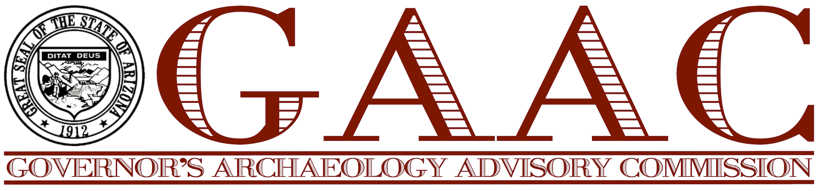

2020 AWARDS IN PUBLIC ARCHAEOLOGY

NOMINATION FORM

NOMINATIONS MUST BE SUBMITTED BY MONDAY, MARCH 2, 2020020

Nominator’s Contact Info
Name:
Title/Affiliation:
Phone Number:
Email Address:
Mailing Address:
Name of Individual(s), Team(s), Organization(s), or Project Name:
Primary Contact Person:
Title/Affiliation:
Phone Number:
Email Address:
Mailing Address:

Nomination Category(s) for which they are being nominated:
_____ Professional Archaeologist _____ Private, Non-Profit Organization
_____ Avocational Archaeologist _____ Government Agency
_____ Site Steward _____ For Profit Corporation
_____ Tribe _____ Special or Lifetime Achievement

Nomination Justification: (please feel free to use additional pages and/or include attachments and digital images on a CD, DVD or Flash Drive in TIFF, JPEG or PNG format.)

NOTE: Letters of support from additional parties may also accompany the nomination (or be submitted prior to the deadline). Such letters, although not required, may be helpful to GAAC members in evaluating nominees.

